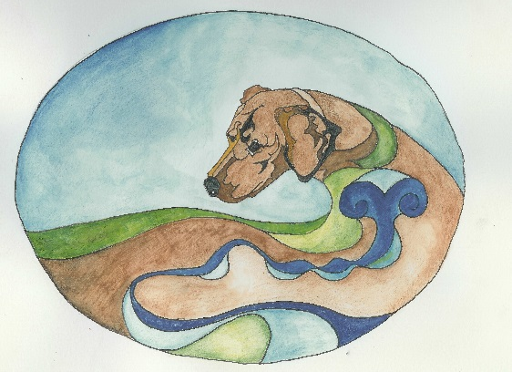
FIRST ANNUAL
Raisin River R. Ridgeback club of MI
BEST RIDGE CONTEST!!!!
SATURDAY, JULY 7, 2018
JUDGE: THERESA LYONS
ALL PROCEEDS TO GO TO RESCUE, SO COME OUT AND HAVE FUN WITH US!!!
BEST ORIGINAL RIDGE (FOR ALL OF OUR DESIGNER RIDGIES), BEST MALE RIDGE, BEST FEMALE RIDGE
PRIZES: R4COM MEDALLION, ROSETTES, BEAUTIFUL COLLARS DONATED BY GLASS CREEK RIDGEBACKS – MARY HODGES!!
- PARTICIPANTS MUST BE 6 MONTHS OF AGE OR OLDER
- CONTEST TO BEGIN FOLLOWING CATERED LUNCH AFTER CONFORMATION JUDGING, APPROX. 1:30 PM OR AS SOON AS RING IS PROVIDED, ANNOUNCEMENT AT LUNCH.
- RING AND ARMBANDS PROVIDED DAY OF EVENT
- SINCE THIS IS A FUND RAISER, NO REFUNDS AVAILABLE
- ORDER OF EVENT, BEST ORIGINAL RIDGE, BEST MALE RIDGE, BEST FEMALE RIDGE
DEADLINE FOR PRE - ENTRIES: JUNE 25, 2018
PRE-REGISTRATION $10, DAY OF EVENT $15 (CUT OFF FOR DAY OF REGISTRATION, NOON)
PLEASE MAKE CHECKS OUT TO: RRRRCOM
PLEASE PRINT OUT ENTRY FORM BELOW AND SEND WITH PAYMENT TO;
ANN TLACHAC, 29110 LAKE PARK DR. FARMINGTON HILLS, MI 48331
OWNER NAME: ____________________________________________
ENTRY 1) AKC REG. NAME: _________________________________________ CANINE D.O.B.______________
CANINE CALL NAME: _________________ CIRCLE ONE: ORIGINAL / DOG / BITCH
ENTRY 2) AKC REG. NAME: _________________________________________ CANINE D.O.B.______________
CANINE CALL NAME: _________________ CIRCLE ONE: ORIGINAL / DOG / BITCH
ENTRY 3) AKC REG. NAME: _________________________________________ CANINE D.O.B.______________
CANINE CALL NAME: _________________ CIRCLE ONE: ORIGINAL / DOG / BITCH

